
Bachelor of Computer Applications
Semester – V

Business Analytics
Experiment No.: 1
Title: Importing business datasets from flat files & MySQL and connecting with any other sources into Power BI
Submitted By:
Name: G Surya Teja
Reg. No: 2411021240017
Date: 22-08-2026
Submitted To:
Faculty Name: Mr. Aman Kumar Sharma
Department of Computer Application Alliance University
Chandapura - Anekal Main Road, Anekal Bengaluru – 562106

Experiment No.: 2
Superstore Business Performance Analysis Using Power BI
Github Repo: https://github.com/suryateja-155/Business-Analysis-Projects/upload/main

Problem Statement
In this experiment, I analysed the sales and profit performance of a retail organization using Power BI. I focused on products, categories, customer segments, and regions to identify important business patterns. I
imported the Sample Superstore dataset, prepared the data for analysis, created DAX measures, and developed interactive visualizations to understand sales performance and profitability.

Methodology / Steps Followed

Step 1: Data Collection
- I obtained the Sample Superstore dataset (SampleSuperstore.csv) from Kaggle.
- The dataset contains 9,994 records and 13 fields.
- The main fields include Ship Mode, Segment, Region, Category, Sub-Category, Sales, Quantity, Discount, and Profit.
- I used the Sample Superstore dataset as the source for analysis from Kaggle

Step 2: Data Import
Power BI Desktop was opened.
- The dataset was imported using Get Data → Text/CSV.
- The SampleSuperstore.csv file was selected and loaded into Power BI.
- The imported data was checked to ensure that all required fields were available.
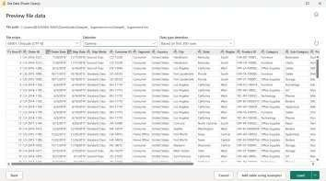

Step 3: Data Cleaning and Transformation
- Data types of all columns were verified and corrected where necessary.
- Sales, Profit, and Discount were set as Decimal Number.
- Quantity and Postal Code were set as Whole Number.
- Duplicate records were checked and removed using Power Query.
- Important fields such as Sales, Profit, Category, and Region were checked for missing values. ● The query and column names were organized for easier analysis.

Step 4: Data Modeling
- A separate Date Table was created using the DAX CALENDAR() function.
- Year, Month, Month Name, and Quarter columns were added.
- The Date Table was marked as an official Date Table.
- A relationship was created between:
DateTable[Date] → Superstore[Order Date]
- The relationship was verified in Model View
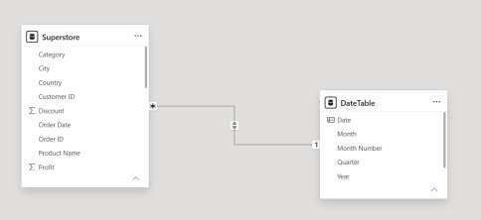

Step 5: DAX Measures Created
The following DAX measures were created to calculate important sales, profit, customer, order, quantity, and discount-related metrics for the Power BI dashboard.
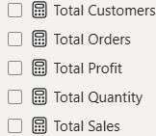
Total Sales = SUM('Superstore'[Sales])
Total Profit = SUM('Superstore'[Profit])
Total Orders = DISTINCTCOUNT('Superstore'[Order ID])
Total Customers = DISTINCTCOUNT('Superstore'[Customer ID])
Total Quantity = SUM('Superstore'[Quantity])
Profit Margin % = DIVIDE([Total Profit], [Total Sales], 0)
Average Order Value = DIVIDE([Total Sales], [Total Orders], 0)
Average Discount = AVERAGE('Superstore'[Discount])
These measures were used across the Power BI dashboard to create KPI cards, charts, tables, and other visualizations for analysing sales performance and profitability.

Step 6: Dashboard Development
- KPI Cards – Sales, Profit, Orders, Customers, Quantity, Margin.
- Sales Analysis – Category, Sub-Category, Region.
- Sales Trend – Monthly/Yearly line chart.
- Top 10 Products – Highest-selling products.
- Profit Analysis – Profit by Category and Region.
- Scatter Charts – Sales vs Profit, Discount vs Profit.
- Donut Chart – Sales by Segment.
- Slicers – Year, Region, Category, Segment, and Order Date.

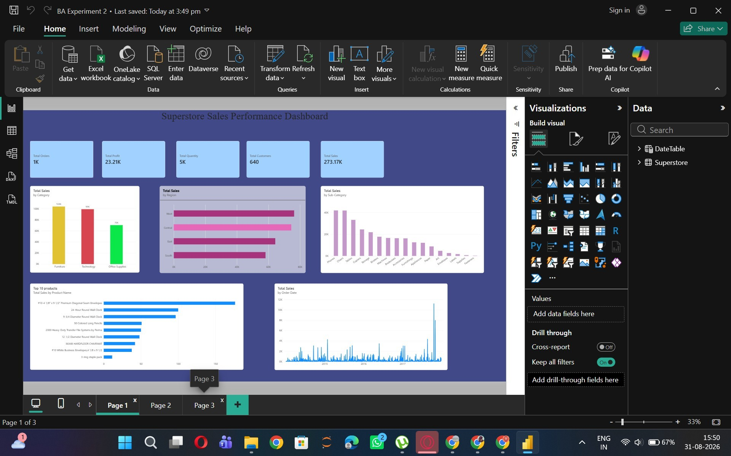
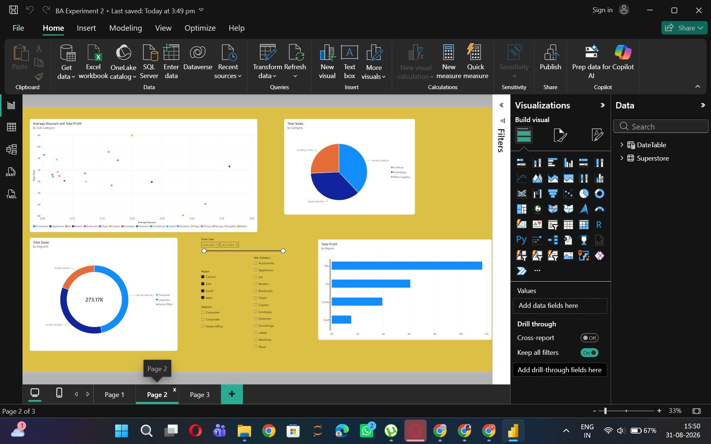
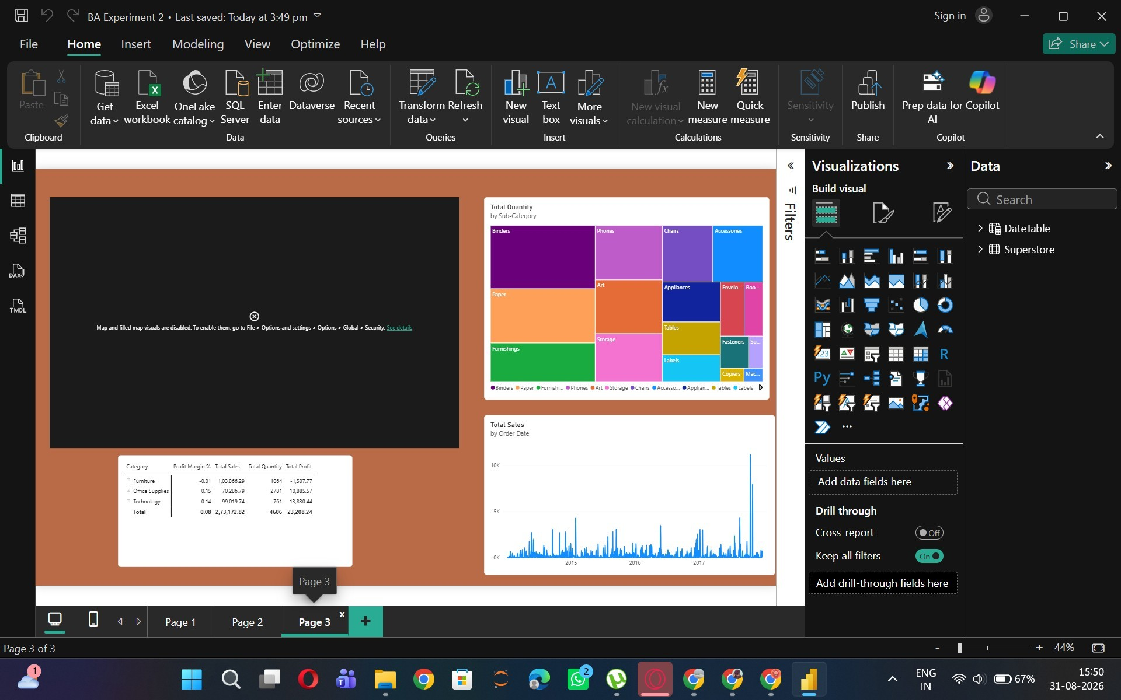

Key Findings
From the dashboard, the following business patterns can be analyzed:
- Technology is one of the major contributors to overall sales.
- Sales performance differs across the four regions, allowing strong and weak markets to be identified.
- The Top 10 Products visualization highlights products that contribute significantly to overall revenue.
- Sales and profit do not always increase together; some products can have high sales but relatively low profit.
- The monthly/yearly trend helps identify periods of increasing or decreasing sales.
- Customer segments contribute differently to overall sales, with the dashboard allowing comparison between Consumer, Corporate, and Home Office.
- Discount versus profit analysis helps management identify whether higher discounts are affecting profitability.
- The category and sub-category analysis helps identify products that may require greater focus or improved pricing strategies.

Conclusion
The Power BI dashboard provides a clear overview of the Superstore's sales and profitability performance. The combination of KPI cards, charts, scatter plots, filters, and product analysis makes it easier for management to identify strong categories, profitable regions, top-performing products, sales trends, and the effect of discounts on profit. The dashboard can therefore support data-driven decisions related to products, pricing, regional strategy, and sales performance.

Learning Outcomes
Through this Power BI project, I learned to:
- Create and use DAX measures for business analysis.
- Calculate important KPIs such as Total Sales, Total Profit, Total Orders, Total Customers, and Total Quantity.
- Use DAX functions like SUM(), DISTINCTCOUNT(), AVERAGE(), and DIVIDE().
- Calculate important business metrics such as Profit Margin, Average Order Value, and Average Discount.
- Understand how DAX measures help in analyzing sales and profitability.
- Use calculated measures effectively in charts, KPI cards, and dashboards.
- Improve my ability to identify business trends and performance indicators.
- Build an interactive Power BI dashboard using the created measures and slicers.
- Develop practical skills in data analysis and business intelligence.
- Learn how Power BI can convert raw sales data into meaningful and actionable insights.

